A CRM Application to Manage the

Services offered by an Institution

By

# Nirupama Deepthi Vaddadi

[nirupamadeepthi06@gmail.com](mailto:nirupamadeepthi06@gmail.com)

# Abstract

The EduConsultPro Institute is a prominent educational organization that annually offers an increasing range of courses and programs to a growing number of prospective students. To maintain their high service standards, they need efficient management across admissions, student inquiries, and expert consultations. This project aims to design and implement a Salesforce-based CRM application to enhance these processes, elevating the experience for both students and admissions staff.

The CRM will feature modules such as Admission Application Management, Consulting Services Management, and Immigration Case Management. Admission Application Management will allow prospects to apply online while enabling the admissions team to track and evaluate applications with automated notifications. Consulting Services Management will make it easy for students to request expert advice, while consultants can schedule and oversee appointments effortlessly. Immigration Case Management will provide relevant information on immigration-related inquiries.

Key system features include automated workflows, email alerts, comprehensive dashboards, and collaboration tools. EduConsultPro’s new student-facing pages, made seamless and user-friendly through Salesforce CRM, now offer a more transparent and accessible experience. The primary goal of this project is to improve operational efficiency and boost throughput in the admissions process, furthering EduConsultPro’s growth with a scalable and forward-looking platform.

# INDEX PAGE

**Topic Page no**

1. Title 1
2. Abstract 2
3. Introduction 4
4. Create Objects from Spreadsheet 5
5. Create a ScreenFlow for Student Admission Application process 8
6. Create Users 10
7. Create an Approval Process for Property Object 11
8. Create a Record Triggered Flow 13
9. Create a ScreenFlow for Existing Student to Book an Appointment 14
10. Create a ScreenFlow to Combine all the flows at one place 16
11. Create a lightning app page 18
12. Execution Screenshots 19

# INTRODUCTION

EduConsultPro Institute, a prestigious leader in education, is dedicated to streamlining and enhancing its admissions, consulting, and immigration services to better serve a growing student population. With an increase in applications and service requests, the institute is adopting Salesforce CRM to create a more efficient, integrated solution that meets evolving demands.

The project will establish a cohesive CRM platform with robust functionalities, aiming to improve operational efficiency and provide a seamless experience for students and staff. This CRM initiative will include:

Admission Application System: A user-friendly interface enabling prospective students to apply online, supported by automated notifications and detailed reporting for admissions staff to ensure timely and effective application management.

Consulting Services Management : An efficient workflow for handling consulting requests, featuring automated email alerts and a streamlined submission process that allows students to request consultations, schedule appointments, and monitor service statuses within Salesforce.

Immigration Case Management: A dedicated tool for managing immigration cases, allowing students to initiate cases through multiple channels, organize documents, and track progress with ease, enhancing transparency and accessibility.

This project also involves configuring Salesforce objects, developing custom flows, and creating unified app pages in Salesforce Lightning to deliver a consistent, streamlined user experience across all processes. These upgrades are designed to support EduConsultPro Institute’s vision for clarity and efficiency, setting a foundation for scalable growth and future readiness.

# Task1

**Create Objects from Spreadsheet**

The outcome is an optimized services management system for EduConsultPro Institute, leveraging Salesforce functionalities to streamline the integration and handling of institutional data. By enabling object creation directly from spreadsheets, this solution simplifies data import into Salesforce, facilitating effective data management for various institutional needs.

Key objects were designed, including Course, Consultant, Student, and Appointment—each critical to the institution’s operations. Lookup relationships were implemented between Appointment and Student, as well as Appointment and Consultant, ensuring data integrity and ease of navigation. Additionally, a new Registration object was created to store student-course associations and set up lookup relationships on immigration or visa applications concerning student inquiries, connecting Student with Case objects.

To meet EduConsultPro's specific requirements, custom tabs were added for each object, ensuring quick access and organization. The Case object was customized to include specified values for the "Type" field (Immigration and Visa Application) and the "Status" field (Open and In-progress). A new Lightning application, EduConsultPro, was developed to integrate these components, featuring a user-friendly interface with tabs for Home, Students, Courses, Consultants, Appointments, Registrations, and Cases. This optimized setup supports a seamless experience for both system administrators and staff, ensuring efficient, transparent service administration.

## Screenshots:

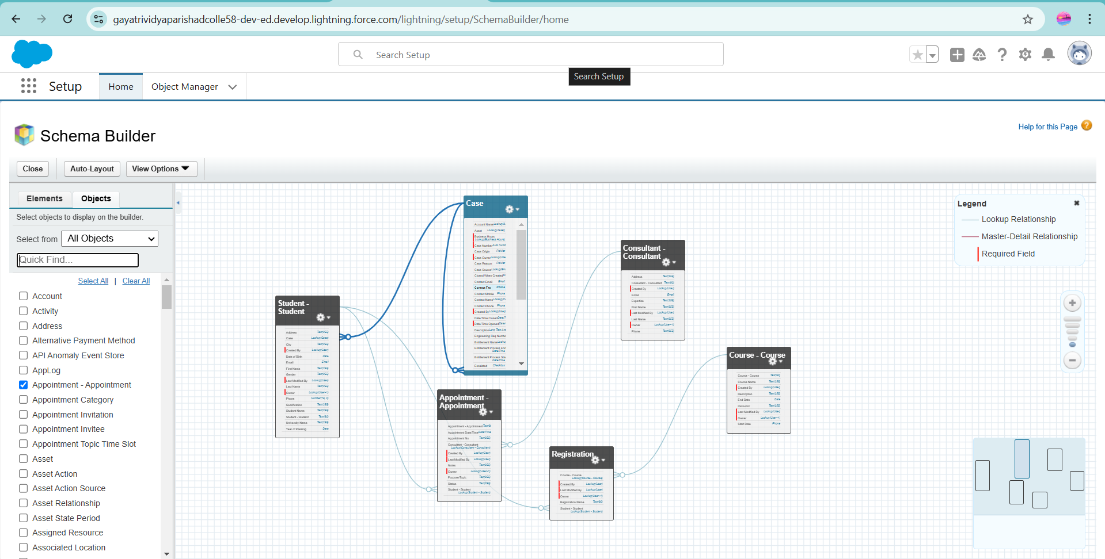

Lookup relationship among Objects

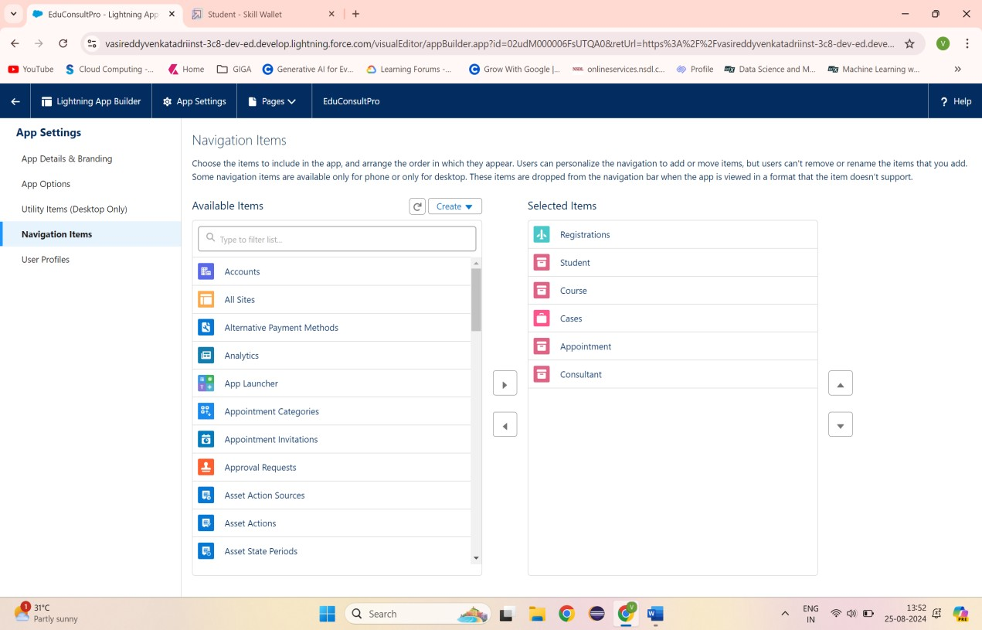Adding items to EduConsultPro

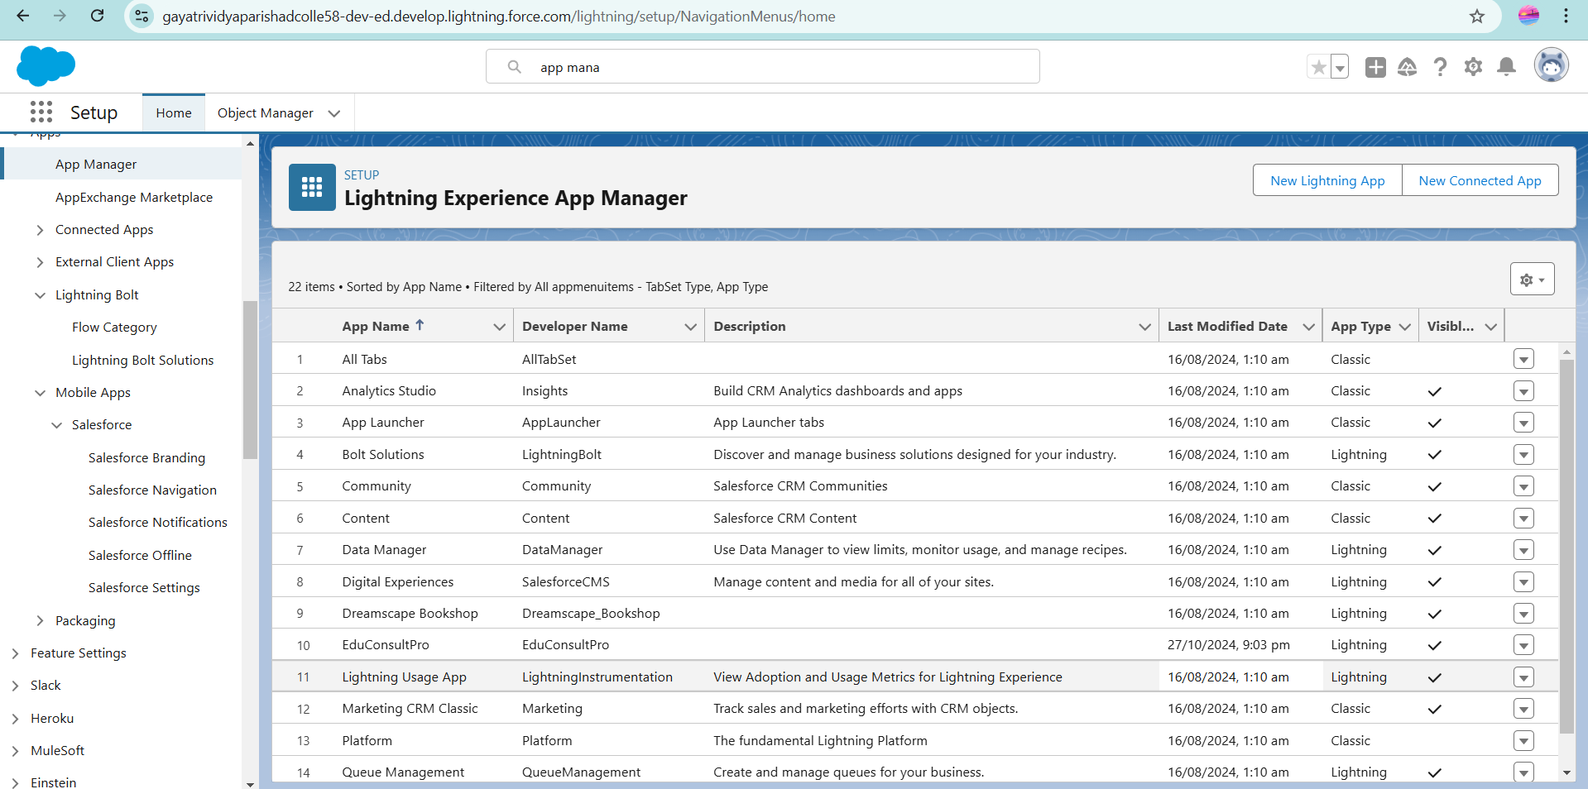



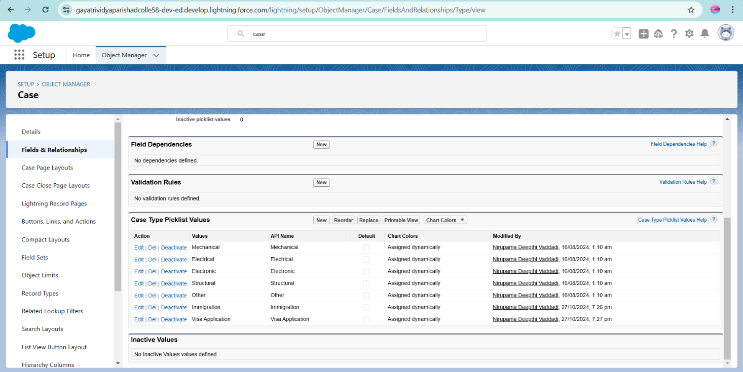EduConsultPro Lightning App

Configuring the Case Object

# Task2

**Create a ScreenFlow for Student Admission Application process**

The **EduConsultPro Student Flow** streamlines the registration process, creating a simpler, user-friendly experience. First, I added a Screen element titled "Student Info" to capture all relevant student details. To access fields from the student object, I created a record variable named **StudentRecordRes**, designed to make data entry light and efficient.

I then developed a Create Records element named "Create Student Record" to save student data in Salesforce. A second Screen element, titled **Course Screen**, was added, featuring a picklist called "Select Course" with options: IELTS, GRE, GMAT, Duolingo, and TOEFL.

To manage course selection, a Decision element called "Selecting Course" was added to guide the flow based on chosen courses. Depending on the selected option, a Get Records element retrieves the matching course from the **Course** object, ensuring accurate registration.

Once course data is gathered, a Create Records element establishes a registration record in the **Registration object**, linking the selected course to the student’s data. I then created Text Template Resources for email content, both subject and body, to notify students of their registration.

An Action element titled "Send Email to Student" sends the confirmation email, auto-populating it with student information upon completion. Finally, to wrap up the flow, a Screen element titled "Success Screen" was added, displaying the message "Registration has been completed successfully," prompting students to check their emails for confirmation details. This complete flow will be titled **EduConsultPro Student Flow.**

## Screenshot:

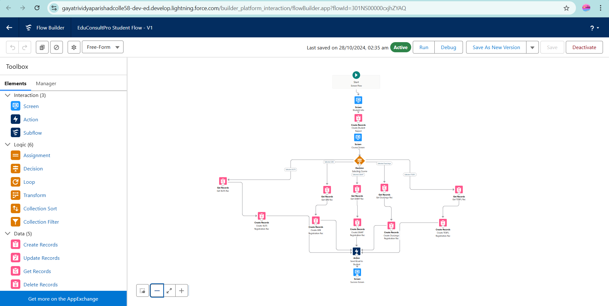

EduConsultPro Student Flow

# Task3

**Create Users**

To create a new user in Salesforce, I navigated to **Setup → Administration → Users → New User**. I entered "Consultant" as the last name and selected "Salesforce Platform" as the license type. I assigned the "Standard Platform User" profile, filled in all required fields, and saved the new user record.

Then, I went to **Setup → Administration → Users → Edit** on the user profile, scrolled to the **Approver Settings** section, selected "Consultant" in the Manager field, and clicked Save at the bottom.

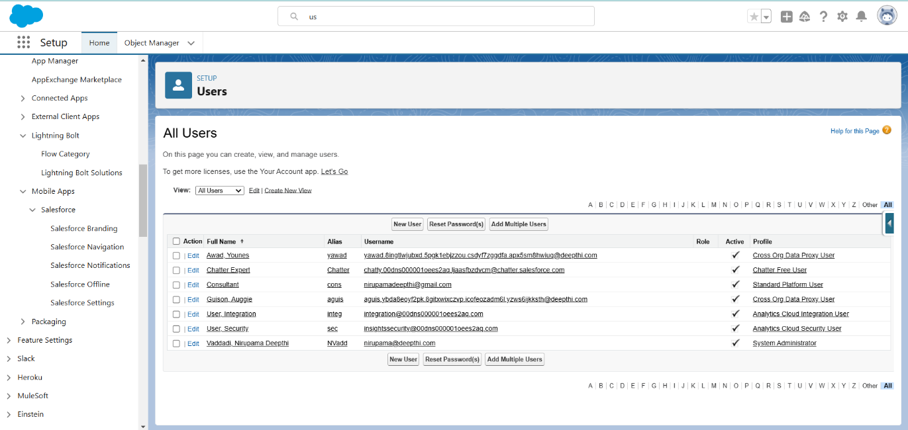

**Screenshots:**

User

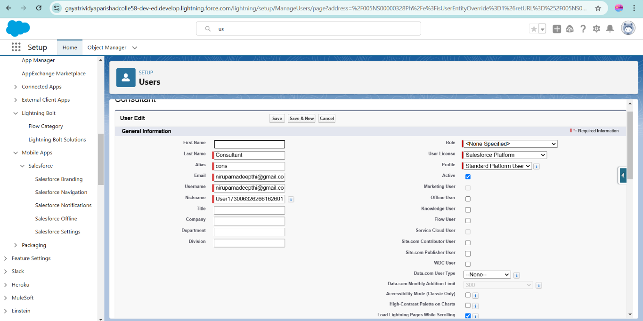



Configure the User Settings

# Task4

**Create an Approval Process for Property Object**

To create an email template in Salesforce, I went to **Setup**, entered "Templates" in the Quick Find box, selected **Lightning Email Templates**, and enabled the toggle. In the App Launcher, I searched for **Email Templates**, saved it, and created a new folder with the desired name. I then created a new email template in the folder, pasting the specified text into the **HTML Value** to form the "Submission Template." Similarly, I designed two additional templates for approving and rejecting requests.

For the approval process setup, I went to **Setup**, typed "Approval" in the Quick Find box, and selected **Approval Processes**. I chose to manage approvals for **Appointment** and clicked **Create New Approval Process** using the Jump Start Wizard. I named it "Appointment Approval" and set the approver to be automatically assigned using the "Manager" field under Option Automatically assign an approver using a standard or custom hierarchy field. I set the Next Automated Approver Determined By to "Manager."

In the **Record Editability Properties**, I specified "Administrator OR the currently assigned approver" and saved the process. I created a Field Update under Initial Submission Actions with the name "Submitted," configuring it to set the **Appointment: Status** field to "Pending."

I also created an Email Alert titled "Submission Email Alert," auto-populated the Unique Name, selected the "Submission Template," and set the recipient type to the user's Name. I repeated these steps for Final Approval and Rejection actions, configuring them in the same way.

## Screenshots:

Email Template

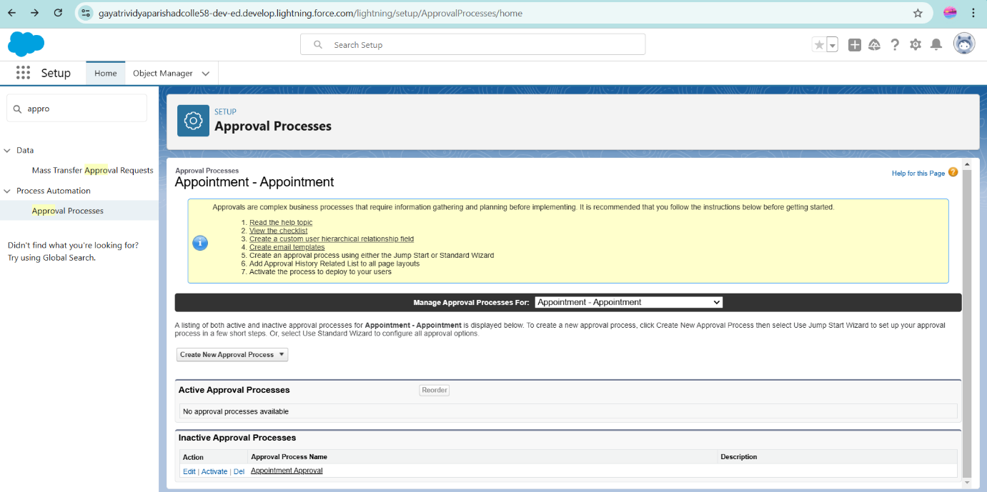

Approval Process

# Task5

**Create a Record Triggered Flow**

I created a record-triggered flow in Salesforce to automate appointment approvals. I set the trigger to **When a record is created** on an appointment record, and added an Action element labeled "Approval SubFlow" to submit the record for approval. I set **RecordId** to "{!$Record.Id}" to ensure the correct record was submitted. Finally, I saved the flow with the label "EduConsultPro Approval Flow" and activated it. This automation now initiates the approval process whenever a new appointment record is created, streamlining the approval workflow..

## Screenshot:

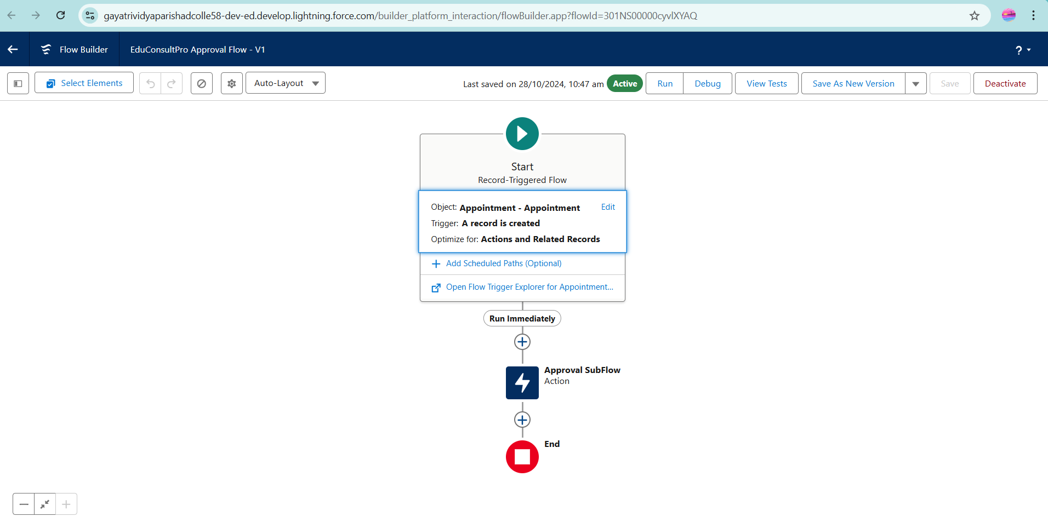

EduConsultPro Approval Flow

# Task6

**Create a ScreenFlow for Existing Student to Book an Appointment**

I configured an end-to-end flow in Salesforce for managing student appointments and cases.

1. I began with a **Screen** element called "Get Student Info" to collect the student's name and email.

2. Added a **Get Record** element to retrieve student details based on the provided name and email.

3. Inserted a Decision element to determine whether the student wishes to book an "Appointment" or create a "Case."

4. For appointments, I added a **Screen** element labeled "Appointment Booking Screen" to gather necessary details.

5. Included a **Get Record** element to fetch consultant details based on the selected consultant’s name.

6. Applied a **Create Records** element to create a new appointment record with the gathered details.

7. Added a **Screen** element called "Confirmation Screen" to display appointment confirmation details.

8. For case management, I included a **Subflow** element named "Create Student Case" to create a case record if the student chose to initiate a case.

Finally, I saved the flow as "EduConsultantPro Existing Student Flow" and prepared it for deployment, enabling a seamless experience for managing appointments and cases in Salesforce.

## Screenshot :

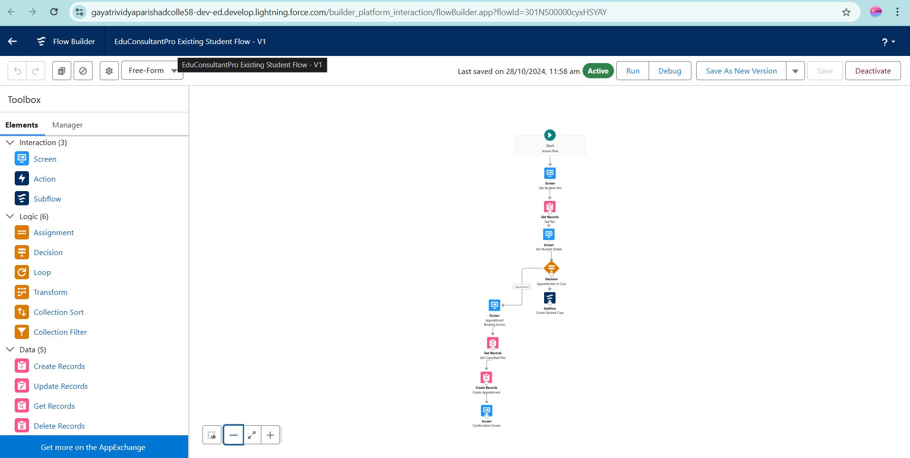

EduConsultantPro Existing Student Flow

# Create a ScreenFlow to Combine all the

**flows at one place**

I added a new **Screen Element** labeled "Welcome Screen" to the flow. Within this screen, I included a **Display Text** component named "SuccessMessage," which contains a welcome message from EduConsultantPro outlining the services and support provided.

Following the Welcome Screen, I added another **Screen Elemen** called "Existing or New Student Confirmation Screen." This screen features a **Radio Button** component labeled "Are you an Existing Student?" with two choices: "Yes" and "No."

Next, I incorporated an Action Element of **type Decision named** "Decision 1," positioned next to the Existing or New Student Confirmation Screen. I configured the decision criteria with the outcome "If Existing Student," where the condition checks if the resource `{!Are_you_a_Existing_Student}` equals the value `{!Yes}`. I added a second outcome for "No."

In the "If Existing Student" path, I inserted a **Subflow Element** and selected "EduConsultantPro Existing Student Flow," labeling it "Existing Student Flow." I saved the flow under the name "EduConsultantPro Existing Student Flow."

In the "If Not an Existing Student" path, I added another **Subflow Element** by selecting "EduConsultantPro Student Flow" and labeling it "New Student Flow." I saved this flow as "EduConsultPro Flow."

Finally, I saved the entire flow, naming it "EduConsultPro Flow," ensuring a seamless experience for users whether they are existing or new students.

## Screenshot:

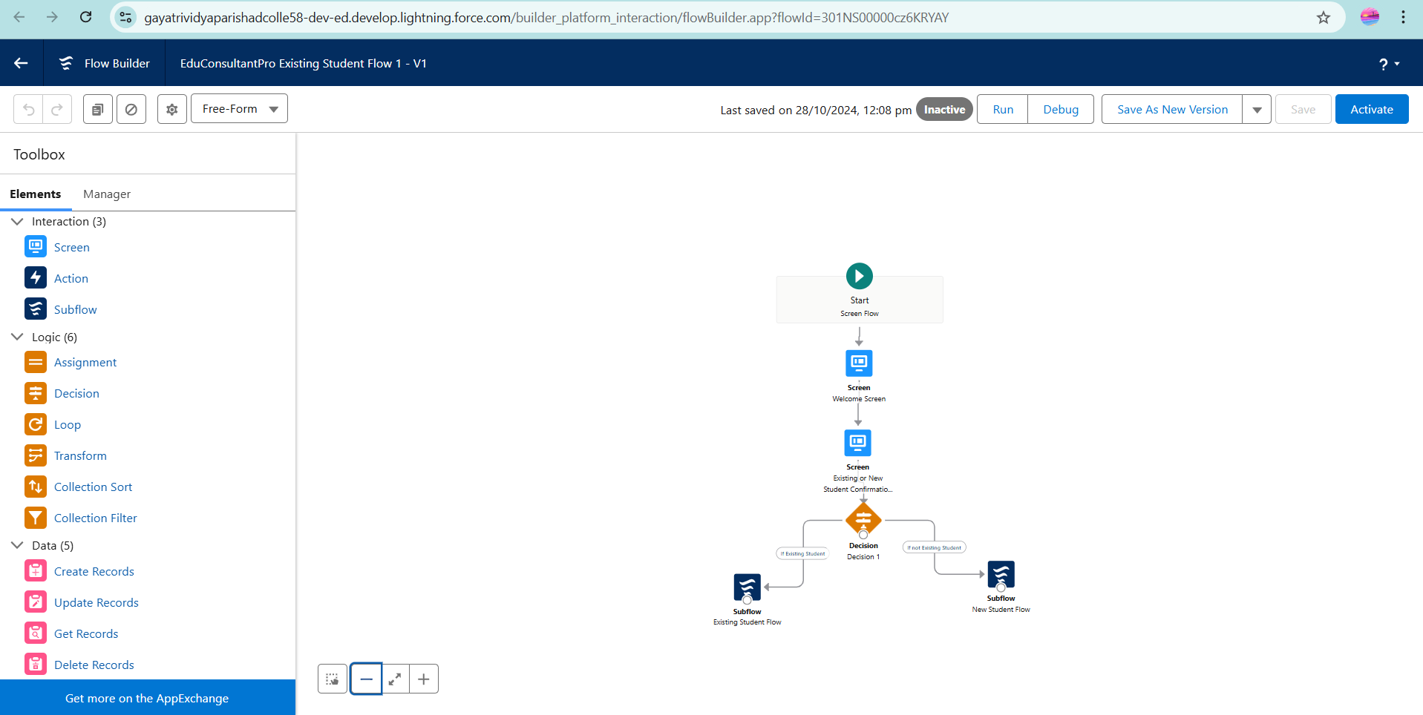

EduConultantPro

# Create a lightning app page

I created and configured a **Lightning App Page** titled "EduConsultPro Home Page" using the Standard Home Page template. In this setup, I positioned the **Flow component** in the top-right region and integrated the "EduConsultantPro Flow." After completing these configurations, I activated the page and assigned it to the Sales app as well as the System Administrator profile, ensuring that it is accessible to the designated users. This setup enhances user experience by providing easy access to the flow directly from the home page.

## Screenshots:

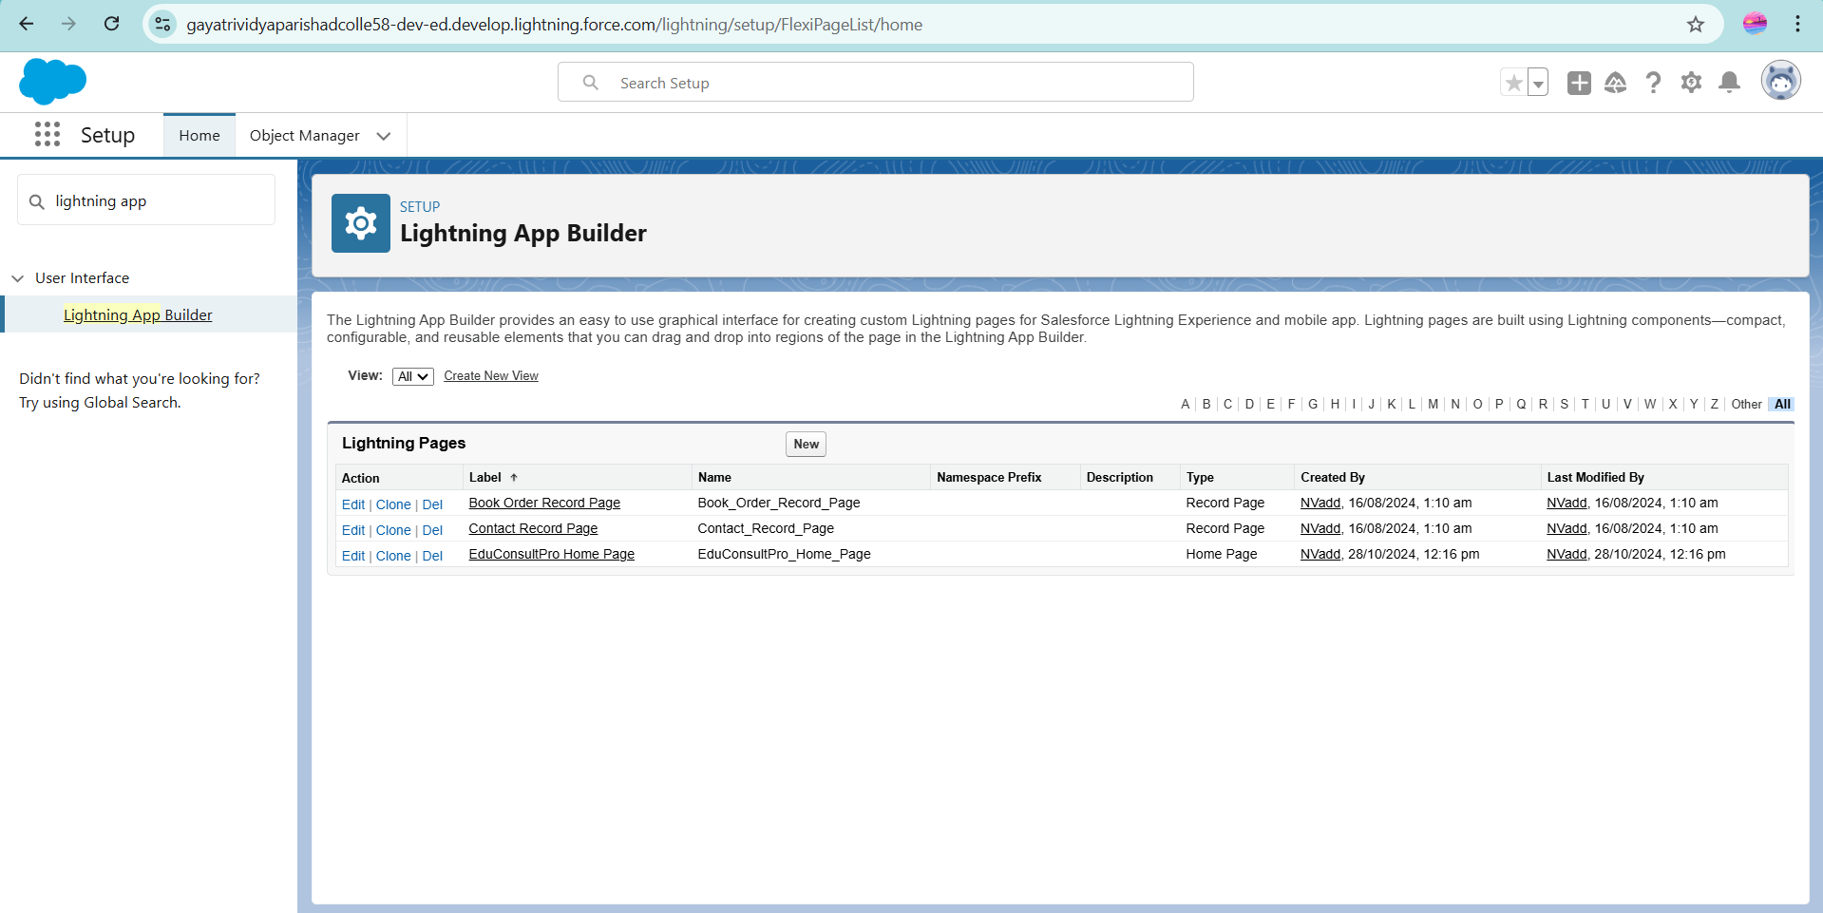

**Trigger Creation:**

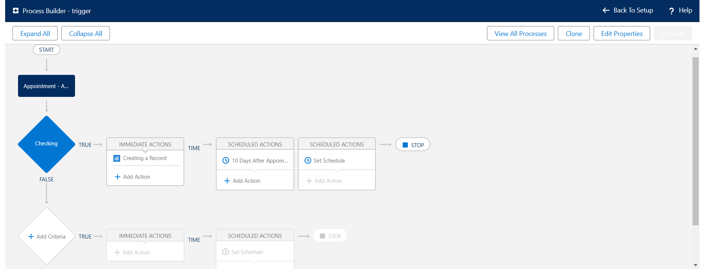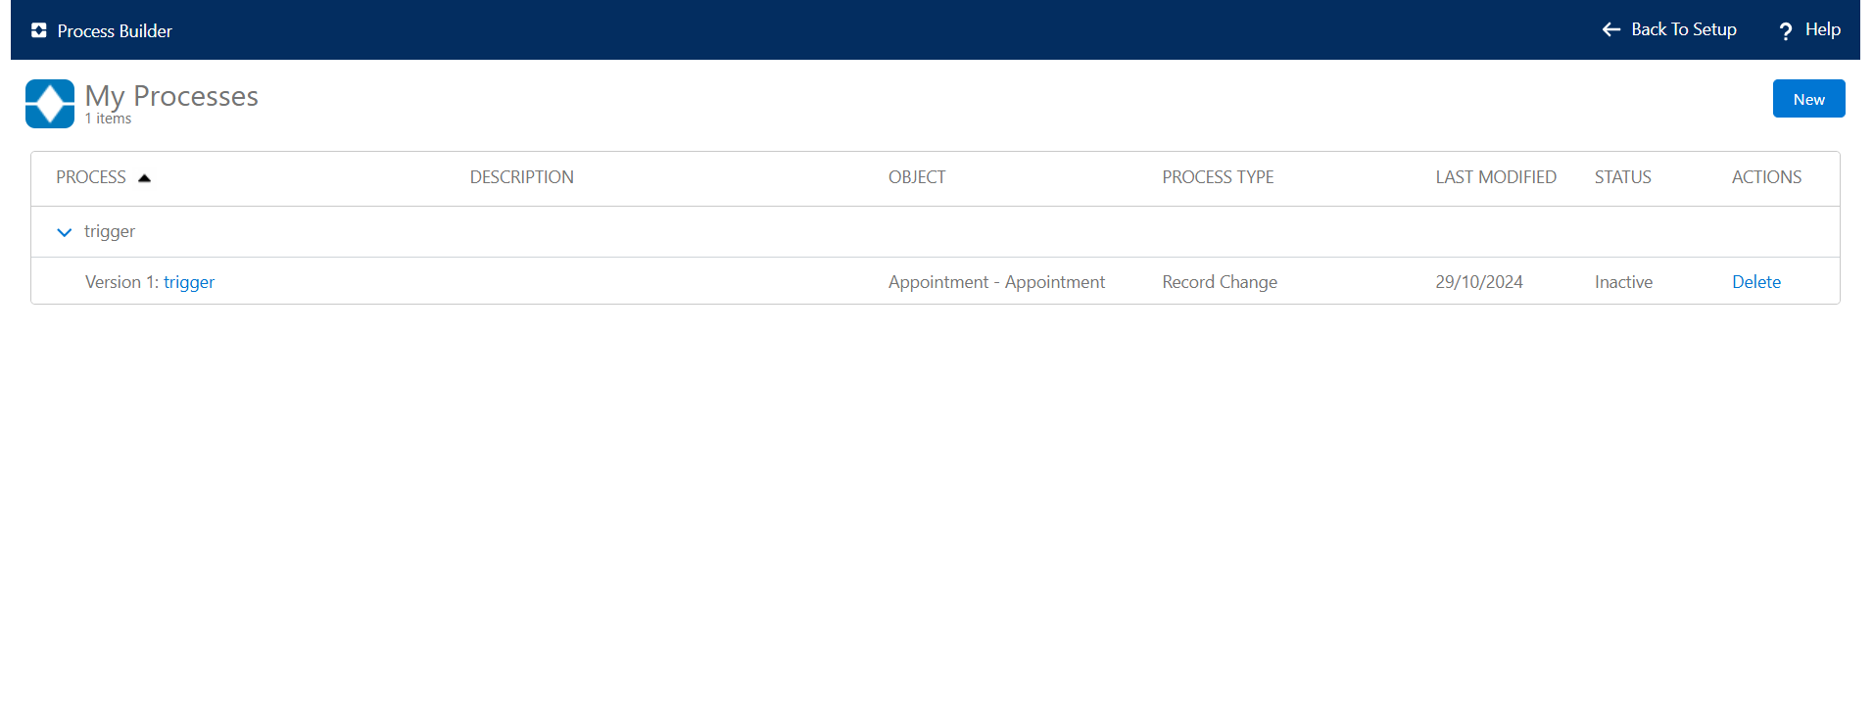

**Execution:**

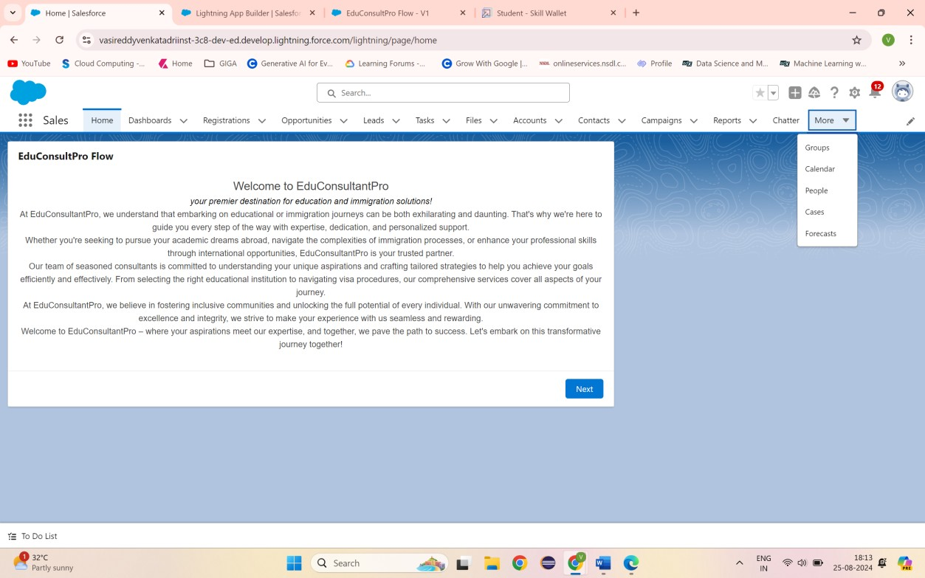

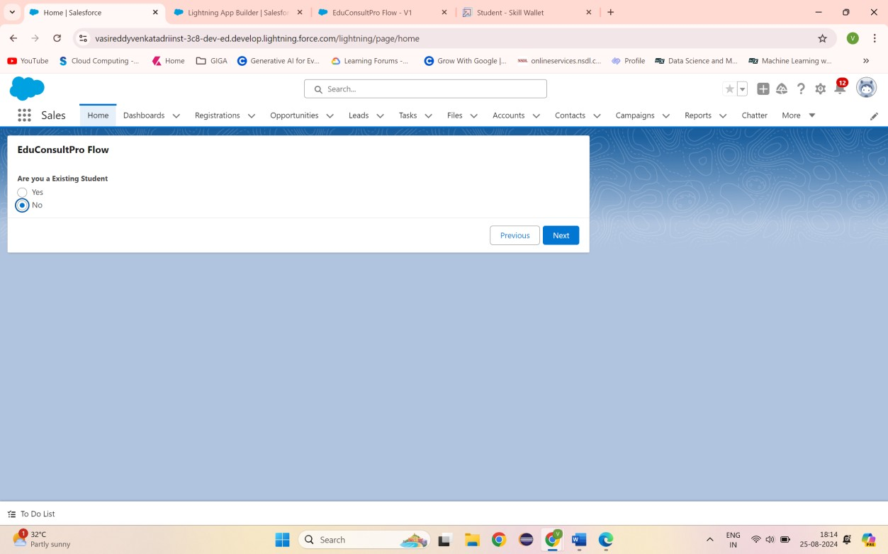

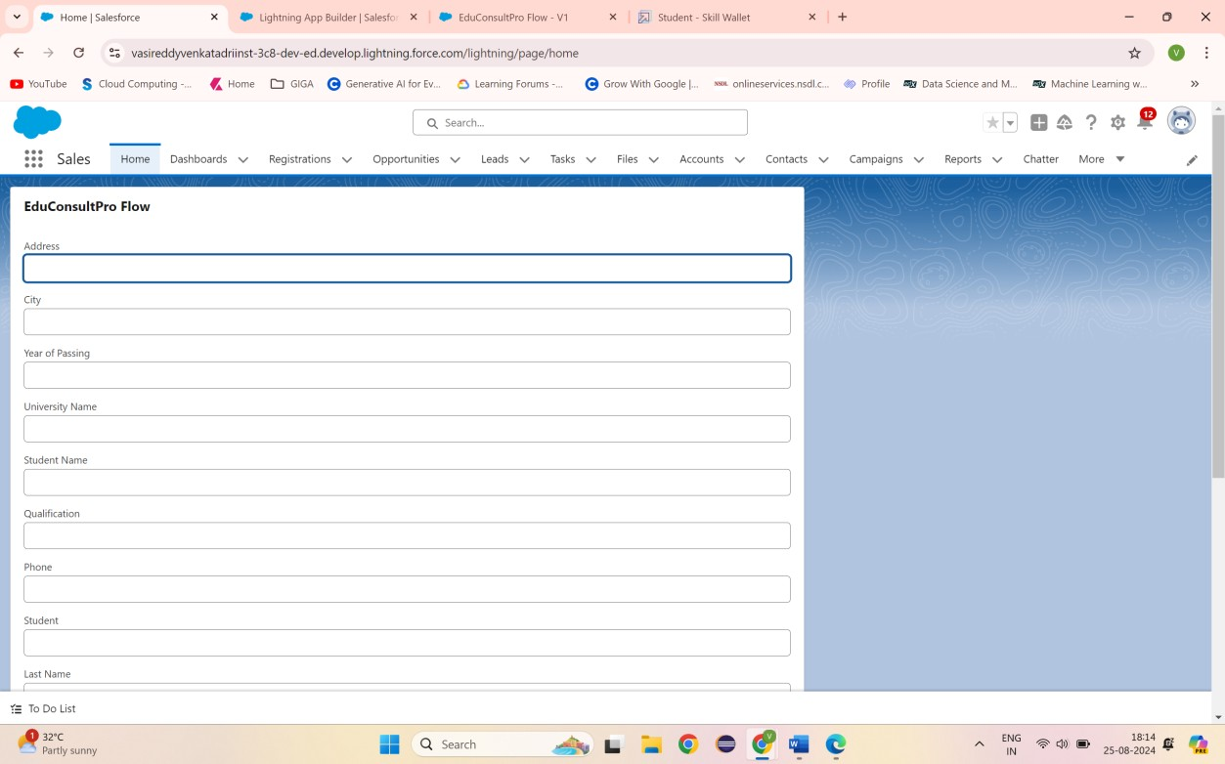

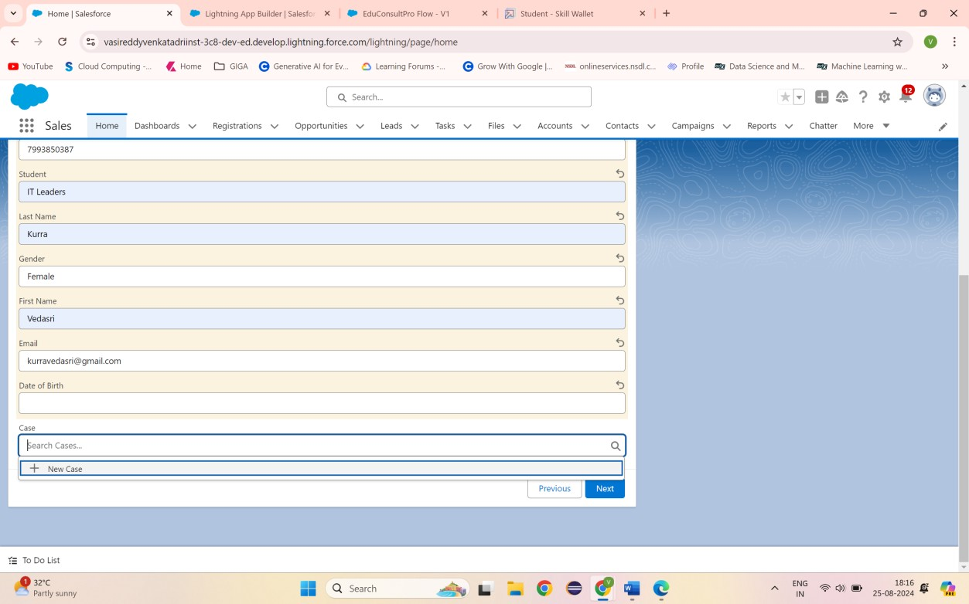

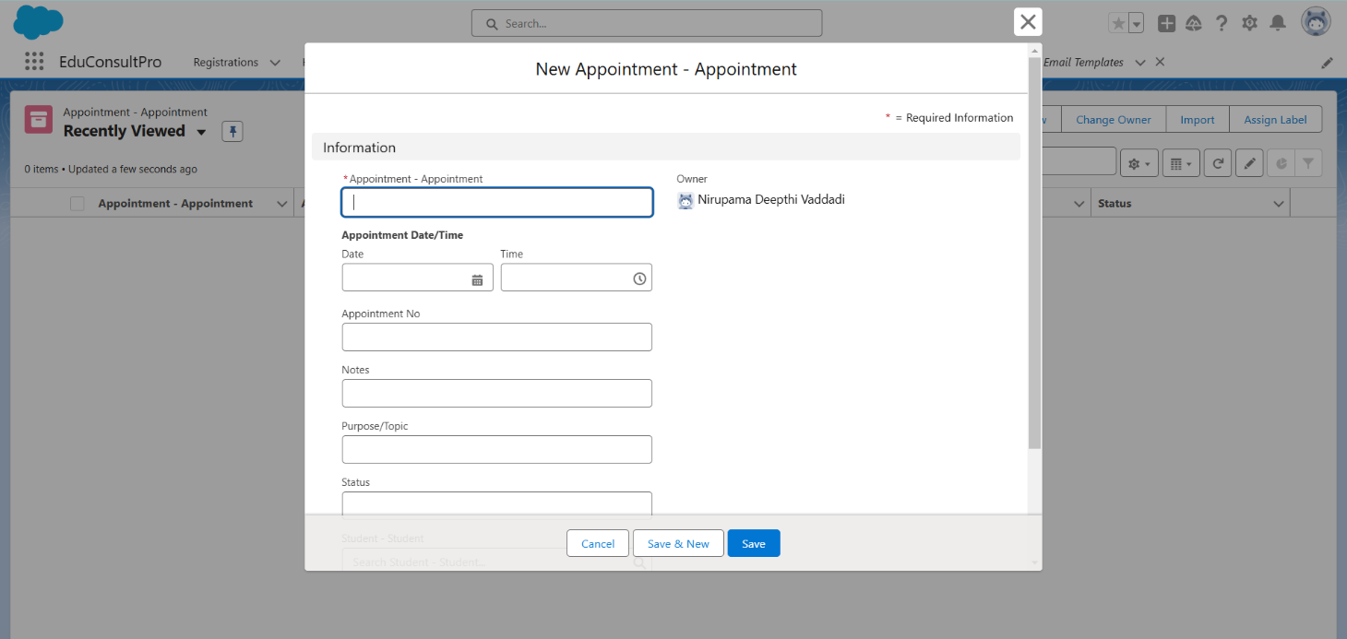

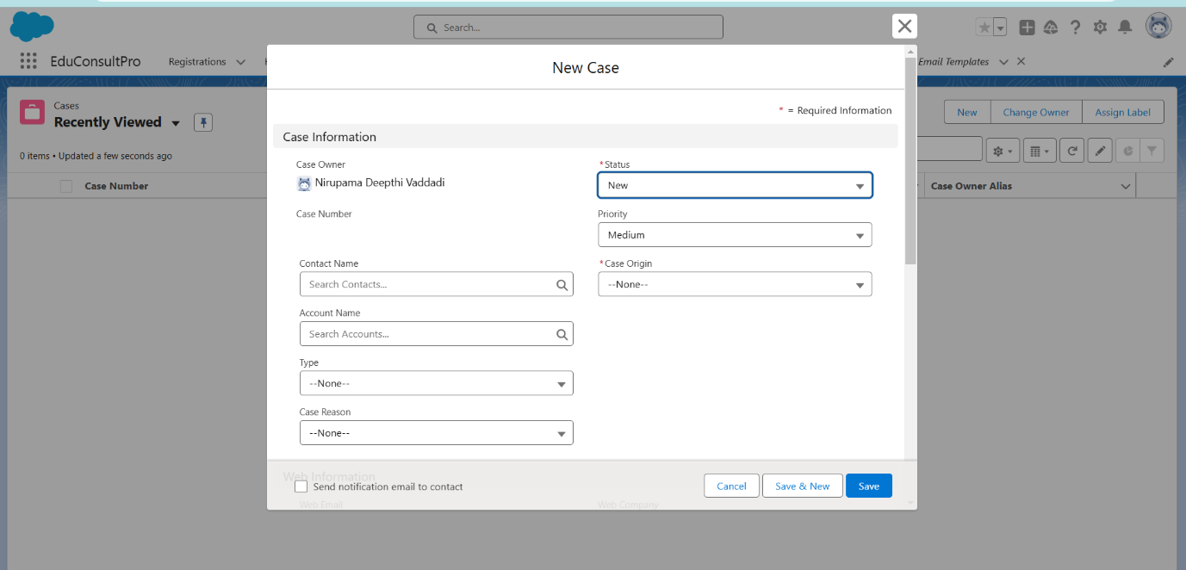

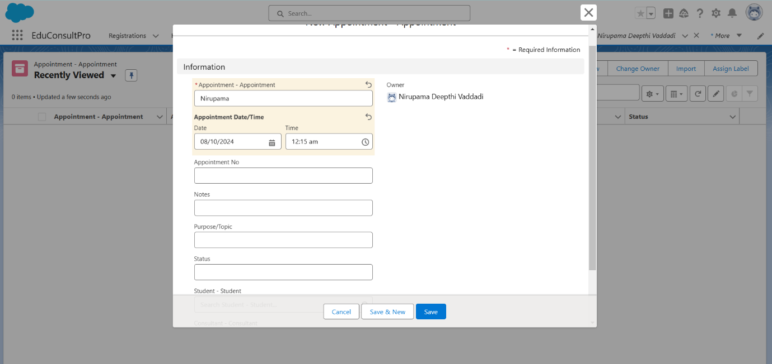

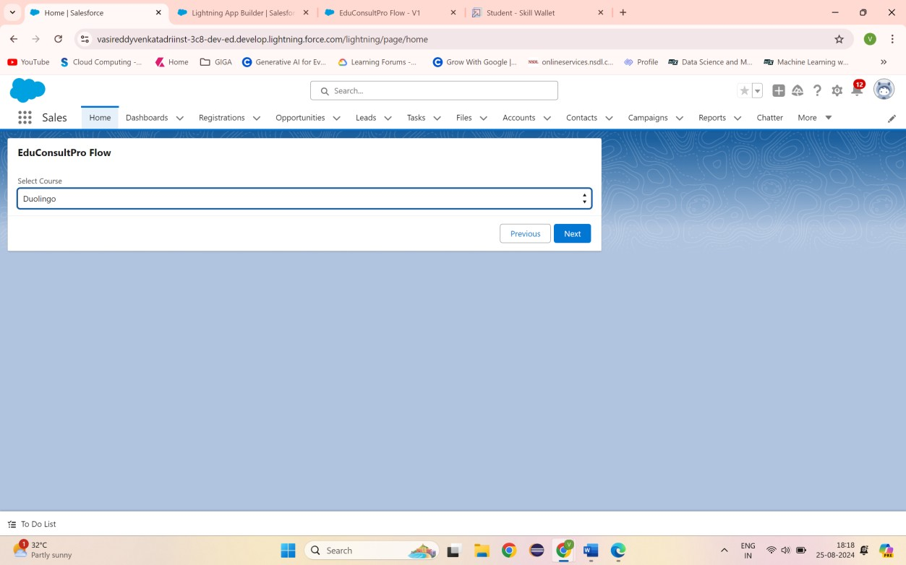

## THANKYOU